**Assignment 3 Javascript Essentials JAN 2021**

**Question 1** Write a JavaScript program to display the reading status (i.e. display book name, author name, and reading status) of the following books.

<!DOCTYPE html>

<html>

<head>

<title></title>

</head>

<body>

</body>

<script type="text/javascript">

var library = [

{

title: 'Bill Gates',

author: 'The Road Ahead',

readingStatus: true

},

{

title: 'Steve Jobs',

author: 'Walter Isaacson',

readingStatus: true

},

{

title: 'Mockingjay: The Final Book of The Hunger Games',

author: 'Suzanne Collins',

readingStatus: false

}];

for (var i = 0; i < library.length; i++)

{

var book = "'" + library[i].title + "'" + ' by ' + library[i].author + ".";

if (library[i].readingStatus) {

console.log("Already read " + book);

} else

{

console.log("You still need to read " + book);

}

}

</script>

</html>

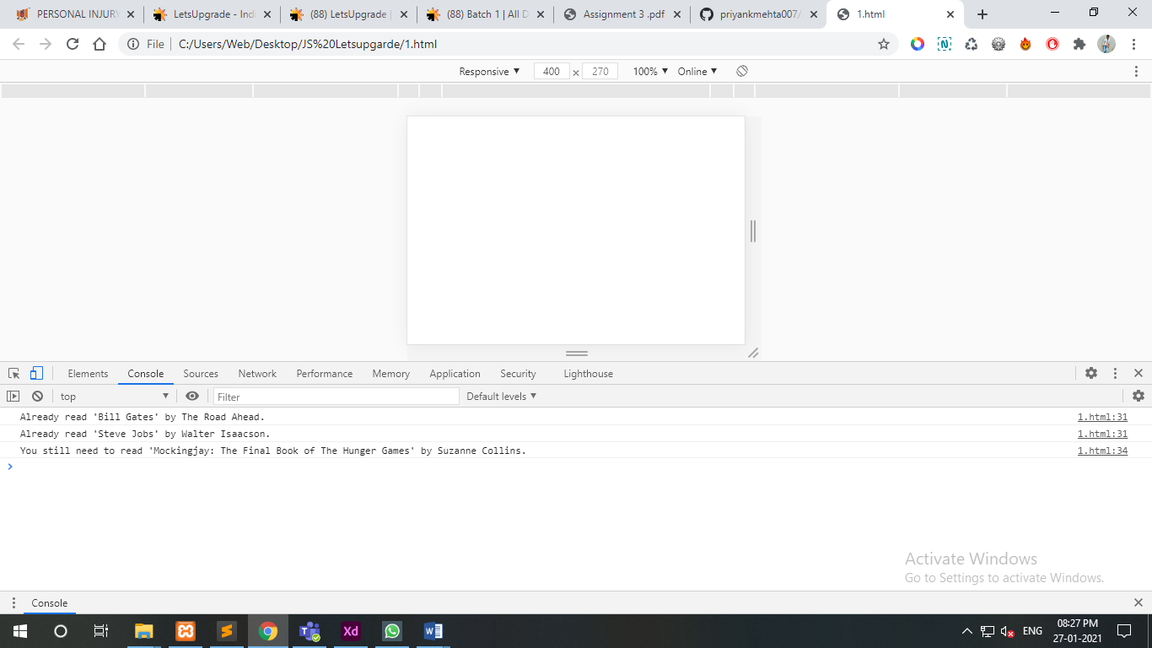

**Question 2** Write a javascript program that generates an alert "Not legal age to drive" if the driver age is below 18 years old, if driver age is greater than or equal to 18, it generates an alert "Drive safe".

<!DOCTYPE html>

<html>

<head>

<title></title>

</head>

<body>

<form name="myForm" action="/action_page.php" onsubmit="return validateForm()" method="post">

Age: <input type="text" name="age">

<input type="submit" value="Submit">

</form>

</body>

<script type="text/javascript">

function validateForm() {

var x = document.forms["myForm"]["age"].value;

if (x == "18") {

alert("Not legal age to drive");

return false;

}

else{

lert("Drive safe");

return false;

}

}

</script>

</html>

